Congratulations Alpha Rho State Members
Who Earned A
National Board Certification!



Donna Matovich – Omicron/2

Claudia Dow – Omega/2

Peg Cowens – Omega/2

Marilee Farr – Omega/2

Susan Faller-Mitchell – Omega/2

Susan Zottola – Omega/2

Lois MacMillan – Omega/2

Mary Jo Huisman – Lambda/2

Karen Adams – Sigma/3

Kelly McIntyre – Psi/5

Andrea Lockhart – Alpha Delta/5

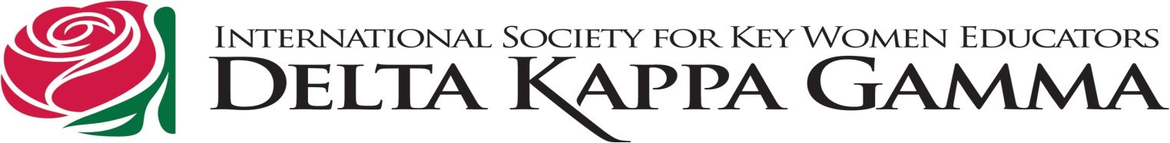
Mary Beth Thouvenel – Pi/6

